# **Format for uploading details in GitHub and Slack in word file format**

**Student Name: Shrinivasa**

**Class and Sec: VI B**

**USN: 4AL17CS092**

|  |  |  |  |  |
| --- | --- | --- | --- | --- |
| **Online Test Details** | | | | |
| **Subject** |  | | | |
| **Semester** | **VI - B** | | **Duration** | **Minutes** |
|  | |  | | |

**Encl: snapshot of the test result**

|  |  |  |  |
| --- | --- | --- | --- |
| **Pre-Placement Training Summary** | | | |
| **Pre placement training** | **9:00 am to 11:00 am - Programming in C++**  **11:00 am to 1:00pm - Programming in C++** | | |
| **Faculty** | **Ms. Shilpa Y Gowda**  **Ms. Ankitha Shetty** | **Duration** | **4 hours** |

**Encl: snapshots of the daily class activities (at least two snap shot)**

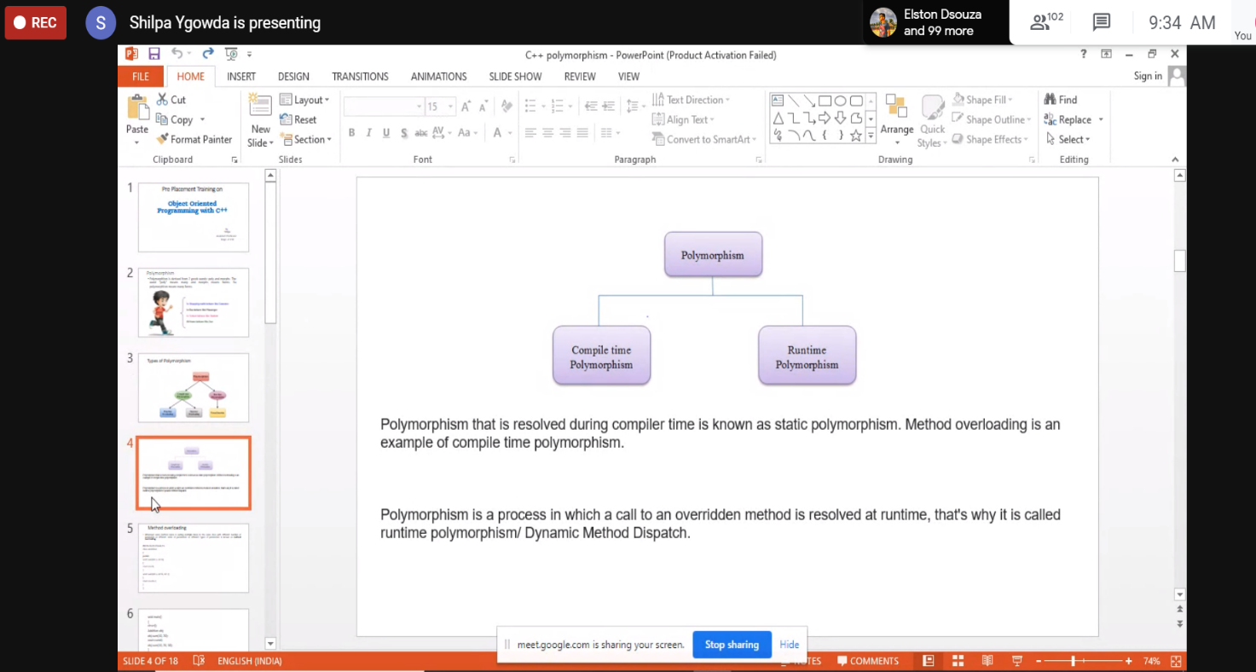

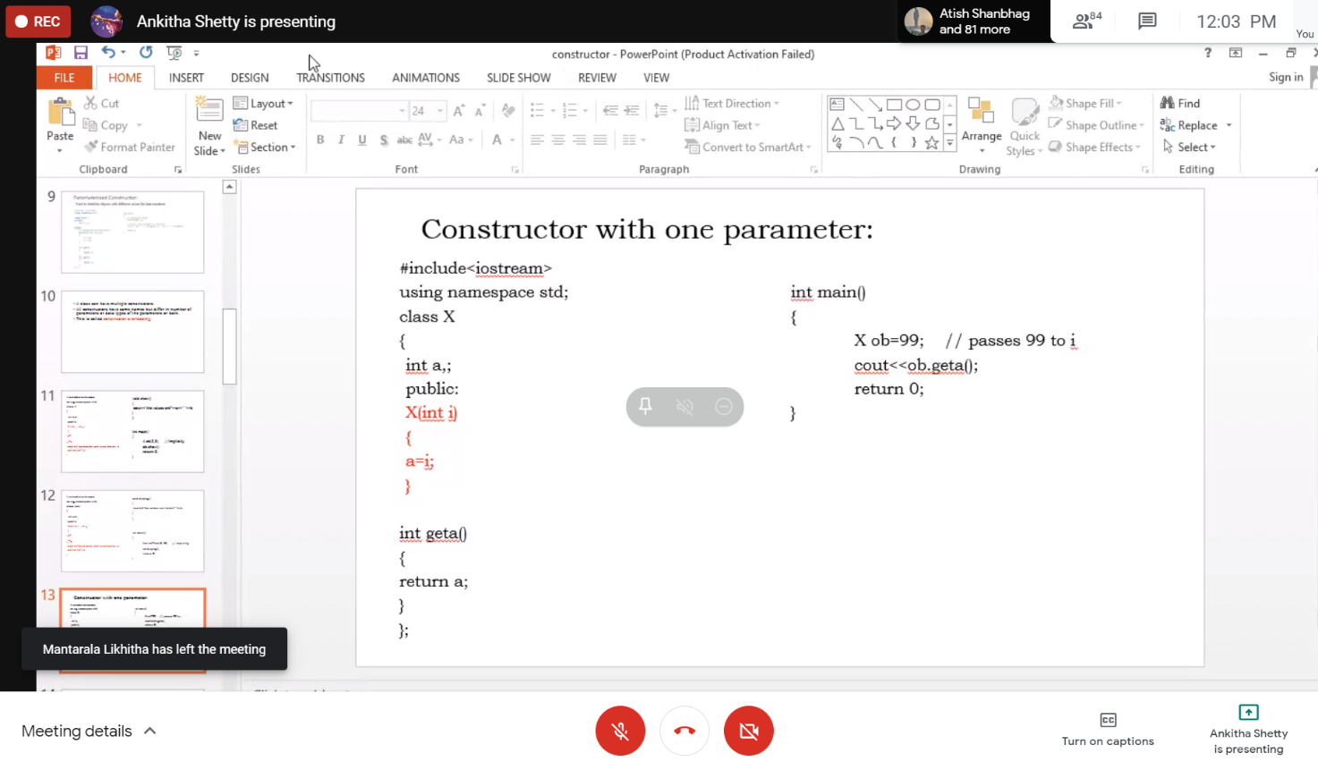

|  |  |
| --- | --- |
| **Coding Challenges** | |
| **Problem Statement: Pro1(java)**  [**https://github.com/Shrinivasakunder/certification-and-online-coding**](https://github.com/Shrinivasakunder/certification-and-online-coding) | |
| **Status: Completed** | |
| **Uploaded the report both in GitHub & Slack** | **Yes** |

**Encl: snapshots of your response to challenge.**

**Pro1(java):**

**Java program to find maximum repeated words from a file.**

**import** java.io.BufferedReader;

**import** java.io.FileReader;

**import** java.util.ArrayList;

**public** **class** MostRepeatedWord {

**public** **static** **void** main(String[] args) **throws** Exception {

String line, word = "";

**int** count = 0, maxCount = 0;

ArrayList<String> words = **new** ArrayList<String>();

FileReader file = **new** FileReader("C:\\Users\\vijay\\OneDrive\\Desktop\\data.txt");

BufferedReader br = **new** BufferedReader(file);

**while**((line = br.readLine()) != **null**) {

String string[] = line.toLowerCase().split(" ");

**for**(String s : string){

words.add(s);

}

}

**for**(**int** i = 0; i < words.size(); i++){

count = 1;

**for**(**int** j = i+1; j < words.size(); j++){

**if**(words.get(i).equals(words.get(j))){

count++;

}

}

**if**(count > maxCount){

maxCount = count;

word = words.get(i);

}

}

System.***out***.println("Most repeated word: " + word);

br.close();

}

}

**Data.txt:**

Shrinivas kunder

Shrinidhi kunder

Kusuma Kunder

Krishna Amin

**Output:**

